Mrs. Szczepanski

(SELF Class, Grades 3-5)

Supply List

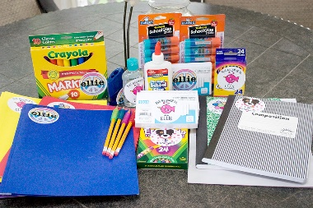

Please send the following items to school with your child: (Please label all supplies with your child’s name)

* A pair of headphones or earbuds for Chrome Book
* A bottom pocket folder labeled “Homework”
* A box of quart or gallon size Ziplock bags
* A 4-pack of dry erase markers
* 1 marble notebook
* A 12-inch ruler
* A plastic supply box to hold the following:
  + A box of pencils (preferably pre-sharpened)
  + A box of crayons
  + A box of markers
  + A pair of safe scissors
  + A package of glue sticks